Homework One

Instruction: The data file for this homework is ToyotaCorolla.xls, which can be downloaded from Canvas. Create a new Word document and save it as HW1Answers_X (where X is your team number). Where required, write your answers/paste screenshots into this Word document. Your response should not exceed 100 words for each below question. Write every member’s full name and participation on the first page of the Word document as follows. You need to submit this Word document and XLMiner solution.

Participant | Complete the Assignment before the Meeting (Y/N) | Percentage of Contribution | Justification
Anchal Atlani | Y | 100 | NA
Nikhil Jadhav | Y | 100 | NA
Soham Dhodapkar | Y | 100 | NA

The dataset contains data on used cars for sale during the late summer of 2004 in The Netherlands. It has 1436 records containing details on 38 attributes, including Price, Age, Kilometers, HP, and other speciﬁcations.
Before building models using various data analytics techniques, we need to verify that the data are in reasonable condition. Exploring data techniques are utilized to help us understanding the global landscape of the collected data, detecting unusual values, cleaning and manipulating data, visual discovery and “hypothesis generation”.
Methods for exploring data include looking at various data aggregations and summarizes, both numerically and graphically. This includes looking at each variable separately as well as looking at relationships between variables. The purpose is to discovery patterns and exceptions. For numerical variables, histograms and box plots can be used to learn about the distributions of their value, to detect outliers, and to find other information that is relevant to the analysis task. Similarly, for categorical variables, we can use bar charts. Scatter plots of pairs of numerical variable can be used to learn about possible relationships, the type of relationship, and to detect outliers. In addition to scatter matrix plot, we can use correlation tables to identify the possible relationship between the variables.
Tasks:
- Which variables are numerical? What are binary? Which are ordinal? Which are nominal?
Answer: In Excel sheet named Variable Categorization.
- Create a table with the average, median, min, max, standard deviation, count blank (the number of records with missing values) for each of the quantitative variables. This can be done through 1) Excel’s functions or 2) Excel’s Data → Data Analysis → Descriptive Statistics menu and then use a excel function for counting missing values.
Answer: In Excel sheet named Data Statistics.

- Use XLMiner to plot a histogram for each of the quantitative variables. Based on the histogram and summary statistics, answer three following questions:
  - Which variable have the largest variability?
  - Which variables seem skewed?
  - Are there any values that seem extreme (outliers)?
Answer:
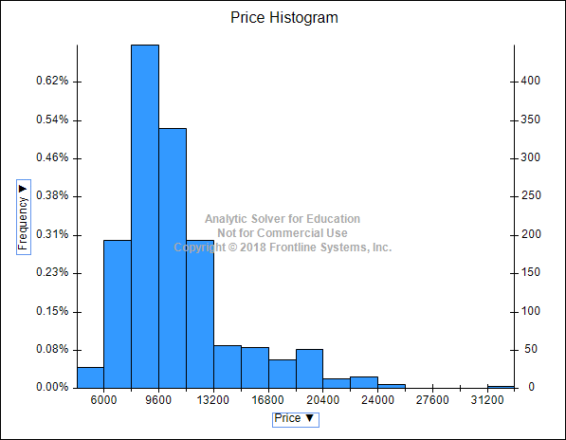
This histogram is clearly right skewed and there is a moderate variability towards the left side of the histogram. As we can see, there are very few models that are on the high end of the spectrum. We can also say that the highest priced models can form a outlier class.

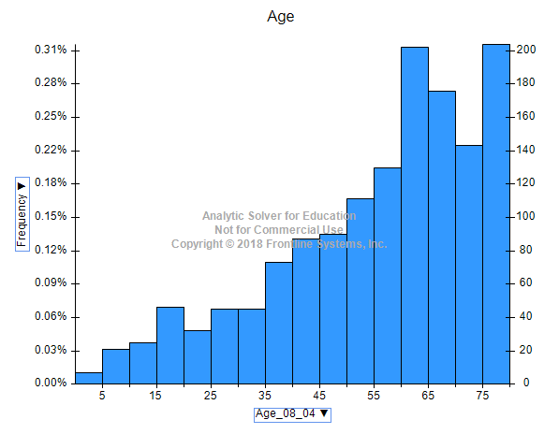
This graph is left skewed. There are no outliers. There is a high variability for this variable as it goes from 0 all the way above 75.

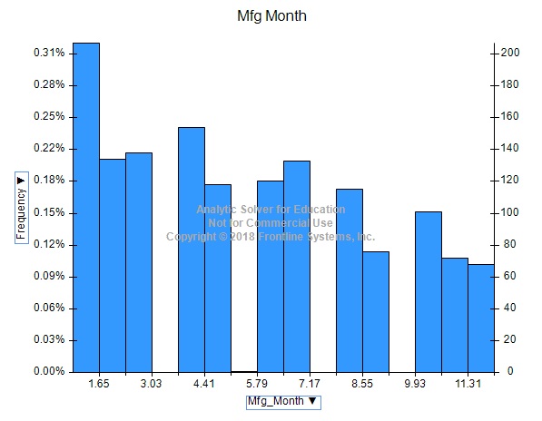
This graph is right skewed but with very short margin.
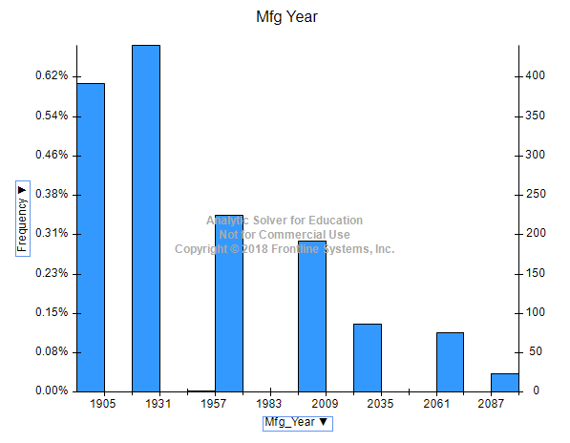
This graph seems right skewed, but by a very short margin. There are no outliers as well.

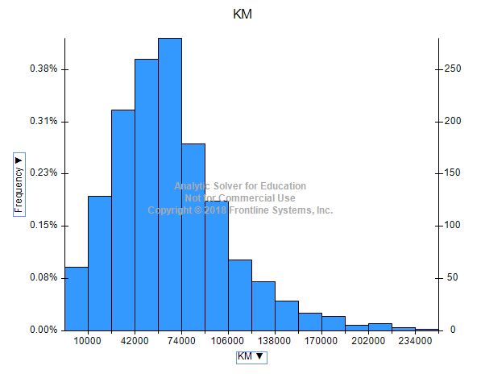
This is a right skew graph as most of the data is present on the left side of the histogram. There are no outliers.

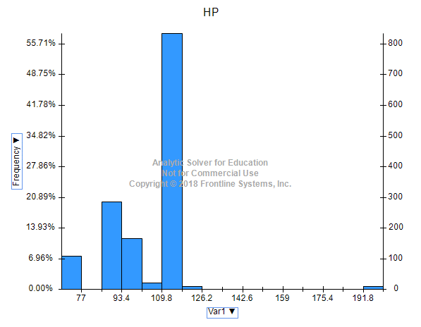
There is no skew in this graph. Data on the right side of the histogram are outliers.

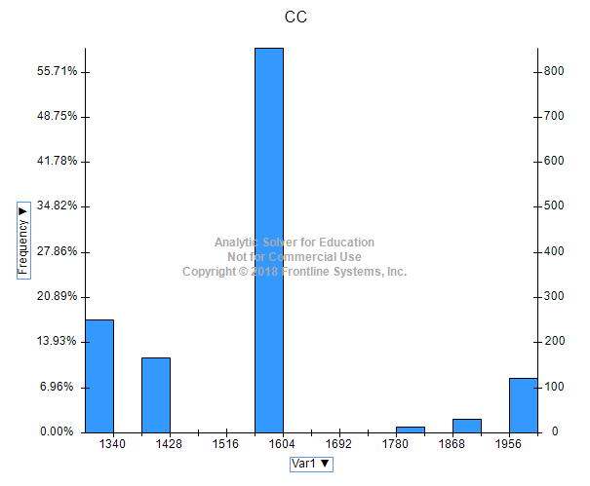
No skew, no outliers and high variability.

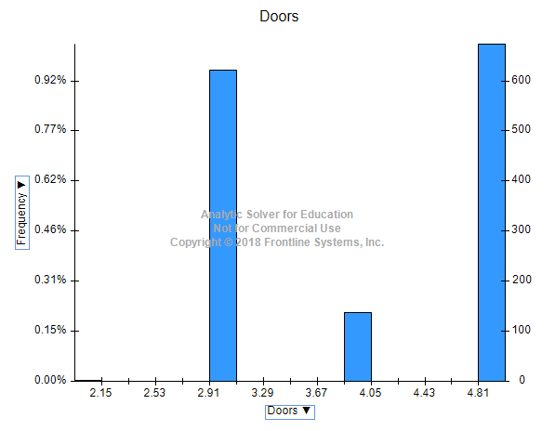
No skew. Data on the leftmost bin of the histogram can be defined as outliers. Low variability.

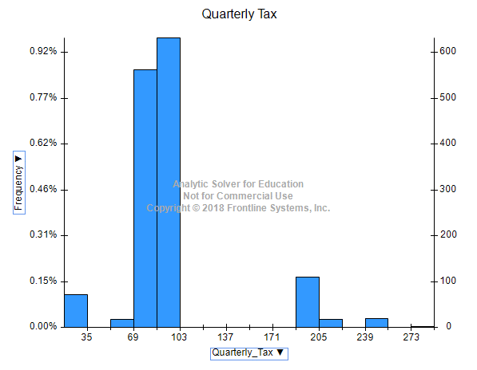
Right skew, moderate variability and no outliers.
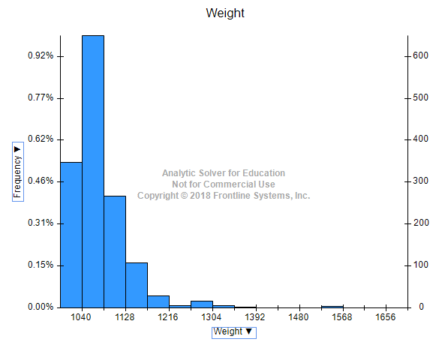
Right skew, moderate variability and the data from 1568 bin can be defined as outliers.
- Compute the correlation table for the quantitative variable (use Excel’s Data → Data Analysis → Correlation menu). In addition, use XLMiner to generate a matrix plot for these variables.
  - Which pair of variables is most strongly correlated?
  - How can we reduce the number of variables based on these correlations?
  - How would the correlations change if we normalized the data first?
Answer: Some answers are in Excel sheet named Correlational matrix with and without price.
- Mostly correlated variables are Weight and Tax.
- Correlation gives us the insight of how two variables are correlated. i.e there is closer the value to 1 duplication of records in both the variables, so removing any of them will not have much effect on our analysis.
- Normalization will not affect the correlation as during the calculation itself we are standardizing the variables. So, if we do normalization first and then calculate the correlation there will be no change. When we normalize, we divide each element with its standard deviation which we anyways perform during correlation matrix calculation hence there will be no change.

- Explore the relationship between price and some of the numerical variables by using scatter plot matrix. What does this plot show us? Present your insights within 100 words
Answer:
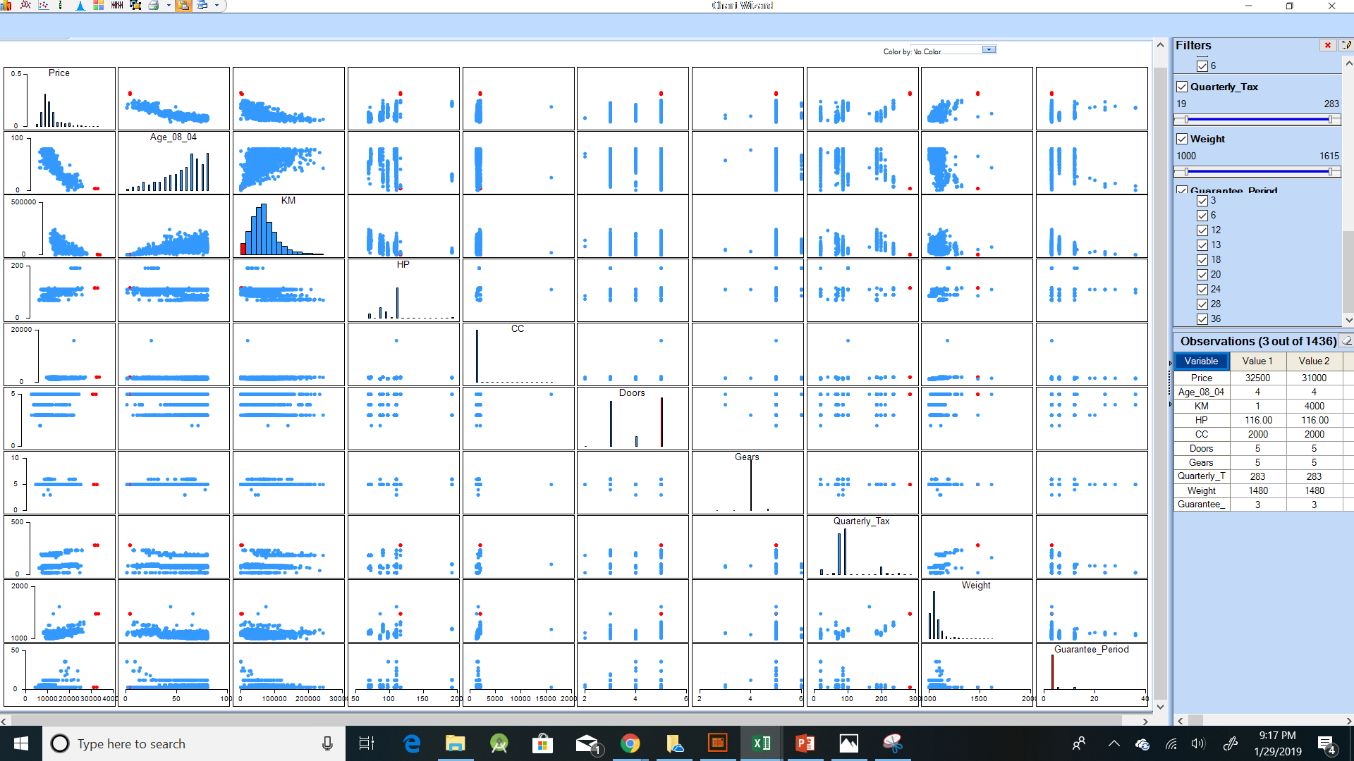
Shown above is the relationship between the price and some of the numerical variables by using scatter plot matrix. After filtering out variables (attribute) which does not provide significant insights we get following scatter plot matrix.
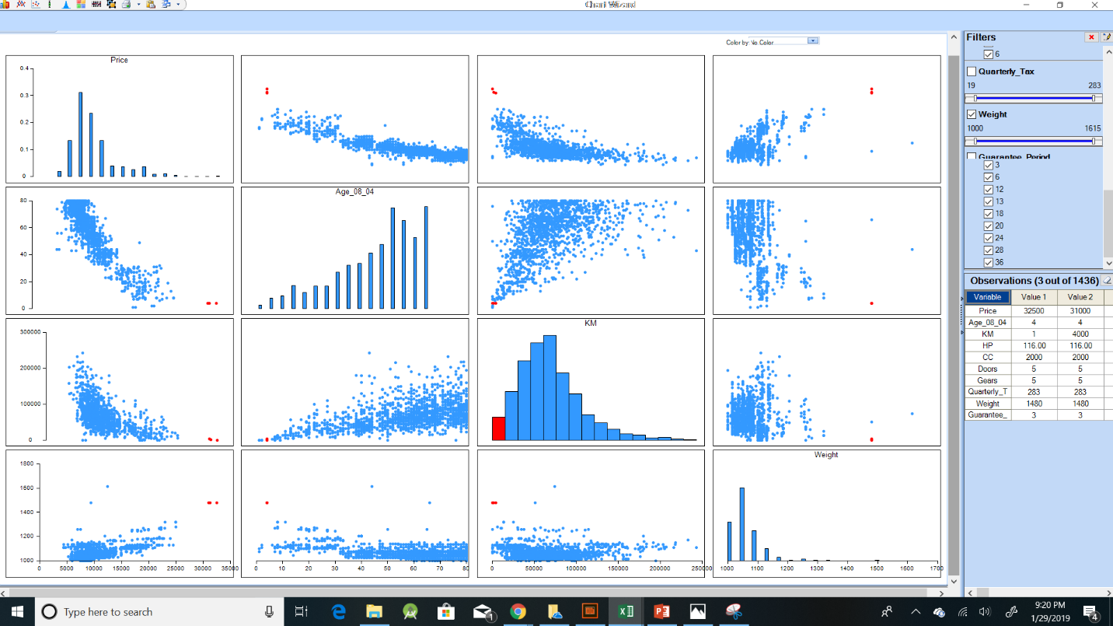
Insights obtained are as follows:
- As the age of car is less the price of car is high i.e. newly introduced cars are expensive
- Using Price and KM relation we obtain the relationship that as the price increases the distance accumulated/travelled by car decreases i.e. Newly released car models have less distance accumulated so far.
- From the price and weight relationship we conclude that expensive car models have higher weight compared to cheap cars which have less weight.

- Explore the relationship between price and the categorical variables by using box plots and Pivot Charts. Which of the pair among variables seem to be correlated? What do these plots and charts show us? Present your insights within 100 words.
Answers:
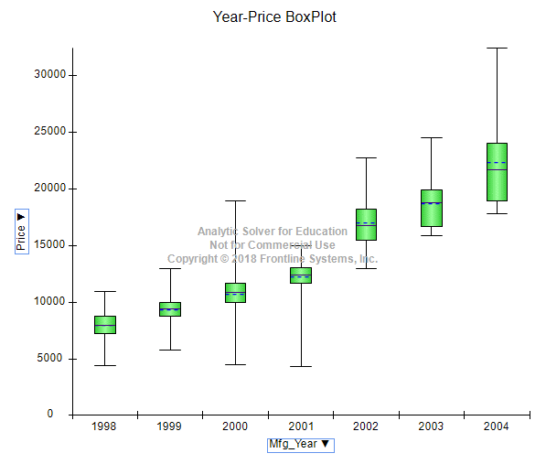

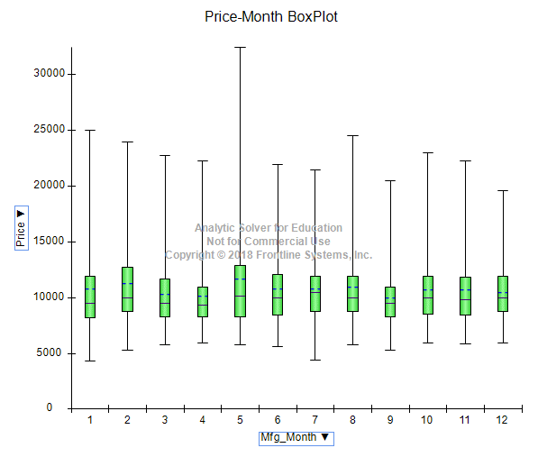

Other BoxPlots location:

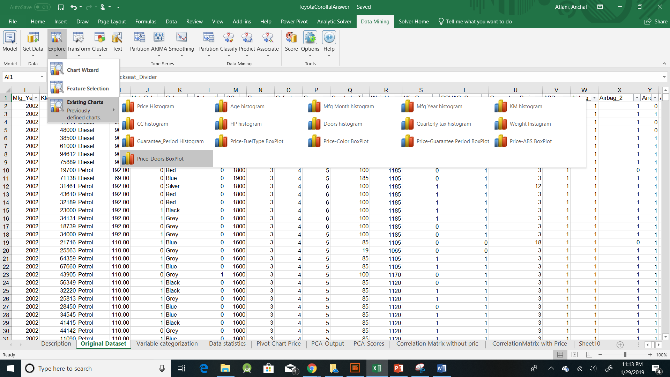

- Describe how you would handle records with missing values.
Answer:
Missing values can be handled in following ways:
- Remove the missing value records: This method can be used when their number of missing values are small in large data set then deleting few records will not have great effect on the prediction. If in the data set count of missing values is high, then this method will not be useful as most of the data will drop.
- Adding the median/mean value for missing data, this will not give any changes in our analysis, but will help us to identify the correlation between other variables.
- We can drop the variable if number of missing values for that variable in many data records is large, this method requires careful consideration and understanding of data, if we can use our knowledge and we conclude that the variable is not of much useful in our analysis then we can use this technique.

- Describe how you would handle records with outliers.
Answer:
Now, how do we deal with outliers? Here are four approaches:
1. Drop the outlier records.
In the case of Bill Gates, or another true outlier, sometimes it’s best to completely remove that record from your dataset to keep that person or event from skewing your analysis.
2. Cap your outlier’s data.
Another way to handle true outliers is to cap them. For example, if you’re using income, you might find that people above a certain income level behave in the same way as those with a lower income. In this case, you can cap the income value at a level that keeps that intact.
3. Assign a new value.
If an outlier seems to be due to a mistake in your data, you try imputing a value. Common imputation methods include using the mean of a variable or utilizing a regression model to predict the missing value.
4. Try a transformation.
A different approach to true outliers could be to try creating a transformation of the data rather than using the data itself. For example, try creating a percentile version of your original field and working with that new field instead.

- Describe how you would convert Fuel Type and Color to binary variables. Conﬁrm this using XLMiner’s utility to transform categorical data into dummies.
Answers: In Excel sheet named: Dummy-binary color, fuel type

- Conduct a principal components analysis on the cleaned data and comment on the results. Should the data be normalized? Discuss what characterizes the components you consider key. Use the “principal components utility in XLMiner”.
Answers:
During PCA we have used correlation matrix and correlation matrix calculation itself involves the normalization of data, so if we are considering correlation matrix then no need to normalize the data
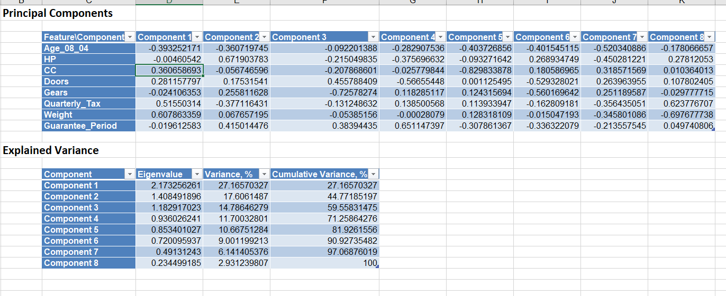

As per the above we can see the first 4 PC have eigenvalue near to 1 and cumulatively they account for 80% percent of variability, so we can take first 4 Principal Components.

Present your insights in a word document. Your insights should not exceed 100 words for each above question.
Modify the worksheets’ titles and names appropriately to reflect the contents.
Important submission instructions
Save your Word file and XLMiner solution. Use the link “Homework 1” to upload these files. Due by 11.59 P.M. Jan. 29, 2019.

